**35)**

**Aim:** To Design Deterministic Finite Automata using simulator to accept strings in which a’s always appear tripled over input {a,b}.

**Diagram:**

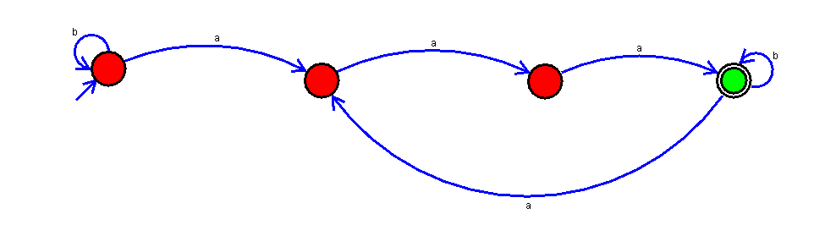

**Result:**

Thus, successfully executed Deterministic Finite Automata using simulator to accept strings in which a’s always appear tripled over input {a,b}.